Press Release
Green Concept Award 2021 Nomination

Spain, L´Hospitalet de Llobraget, 21.04.2021 –1,461 participants from 51 countries applied for the Green Product & Green Concept Award 2021. The Concept EGG-SHIELD was selected as a Nominee for the Green Concept Award 2021 in the Category Circular Materials.

The Green Product & Concept Award is awarded annually to products & concepts that stand out in terms of design, innovation & sustainability. The best 100 products and concepts were nominated and reviewed by jurors – such as Katja Reich (DBZ), Tina Kammer (InteriorPark.) and Prof. Kiersten Muenchinger (University of Oregon).

“EGG-SHIELD is a good example for the level of quality and passion, our nominees are contributing to a more sustainable future.” Nils Bader, Director Green Product Award

“What a visionary idea with splendid material choices.”
Official Green Product Award statement

EGG-SHIELD is a concept that proposes to rethink the final destiny of products. It is inspired by the utopia of living in an ecocentric world which entails a society whose processes, consumption and disposal of things is always loyal to the planet. Waste is no longer waste, but repurposed and harnessed as in this case leftover eggshell is used as an asset for the creation of ephemeral objects and imitates the main purpose of an eggshell: protection. The natural behaviour of the material gives to it, uniqueness, and biodegradable features that demonstrates its circularity.

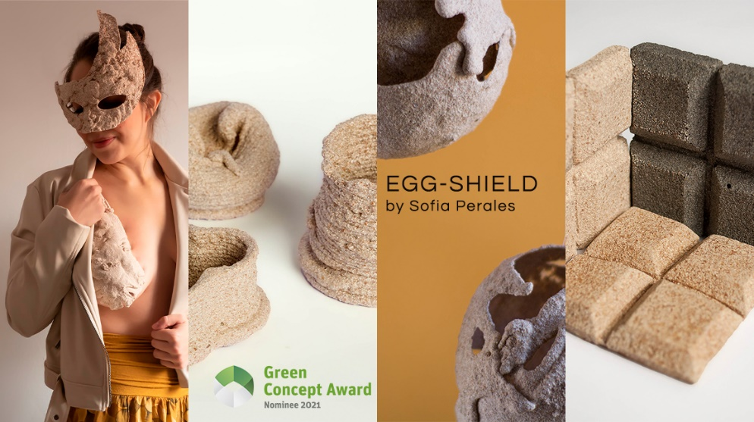

We'd love to see you pick up out your medium and share this green innovation with your audience.

Best wishes
Laura Sofía Perales Viñals
E-Mail: lsofiapv@outlook.com
Tel. +34600098167

About the Awards
The international Green Product Award has been honoring products and services since 2013, which stand out in terms of design, innovation and sustainability. The aim of the prize is to give good examples to the public and to provide feedback and networking opportunities for the participants. The 12 award categories are: Architecture & Tiny Houses, Building Components, Circular Materials, Consumer Goods, Fashion, Handicraft, Interior & Lifestyle, Kids, Kitchen, Mobility, Sport and Workspace. The Green Concept Award recognizes concepts that are not yet on the market. The annual Green Trend Book contains results from the award cycle & trend impulses of international experts.

The awards are organized by the non-profit Green Future Club, which provides designers, researchers and businesses with a platform for an active and hands-on exchange around green innovations. www.gp-award.com/en/gfc

